**Create Node-RED Service**

|  |  |
| --- | --- |
| Date | 10 November 2022 |
| Team ID | PNT2022TMID10394 |
| Project Name | Gas leakage monitoring and alerting system for industries |

**Aim**:

To create a web application, create a Node-RED service.

# Steps to be followed

Step 1: Navigated to the App creation page.

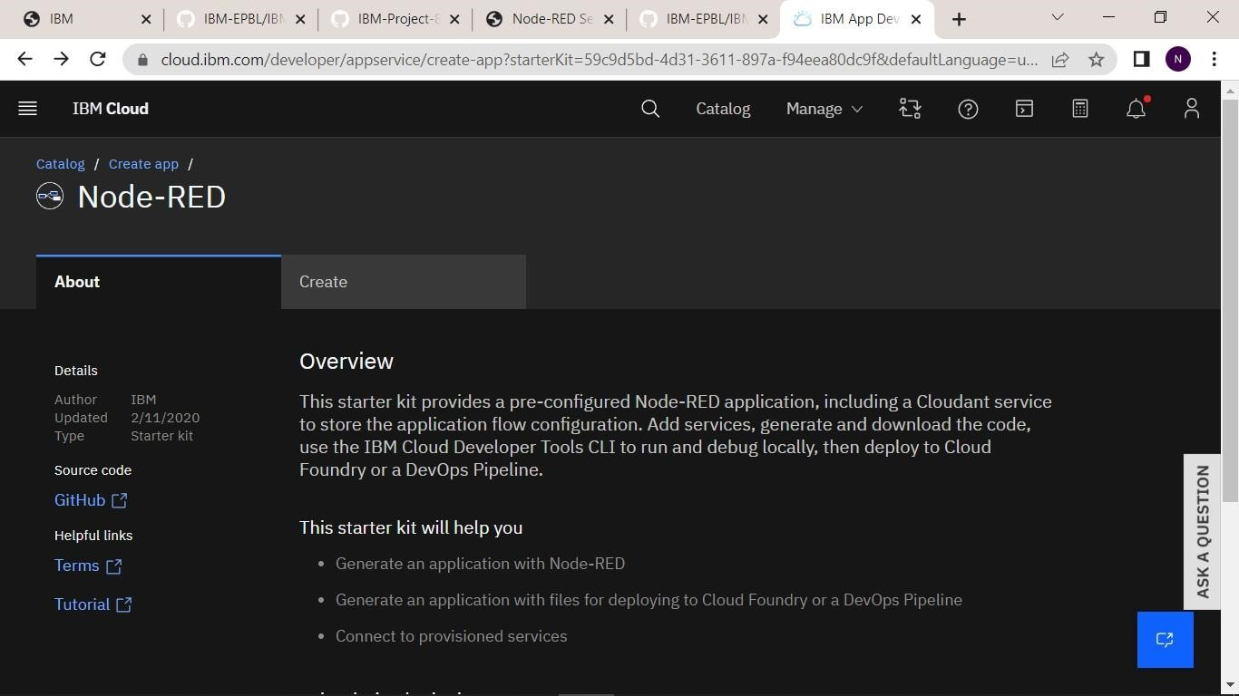

Step 2: Entered project details and clicked on create.

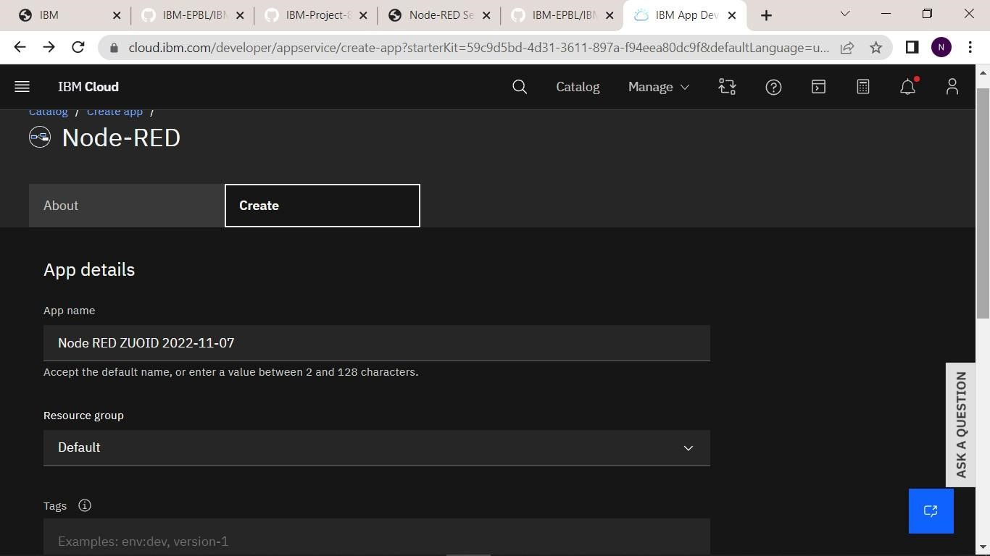

Step 3: Clicking on the “Deploy your App” Button.

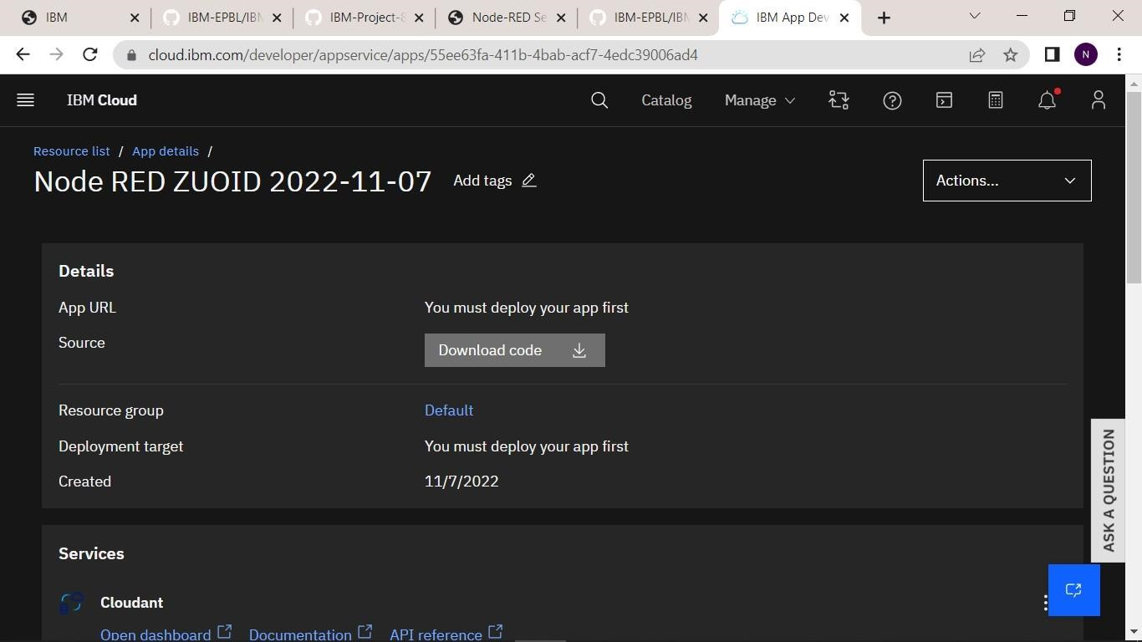

Step 4: Setting up the environment and deploying the app.

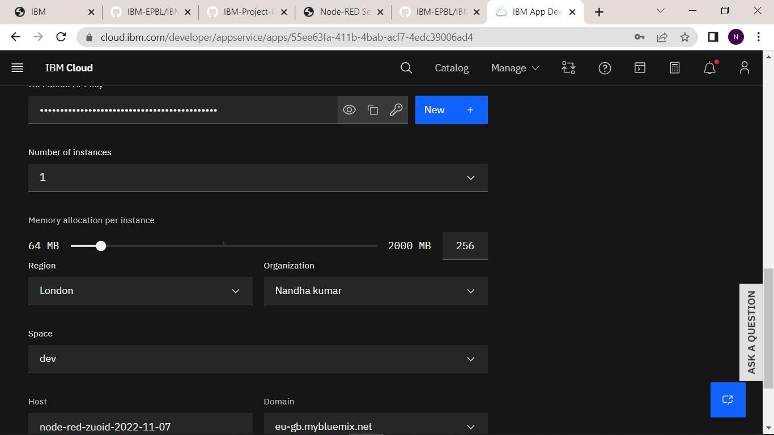

Step 5: Successfully deployed the app.

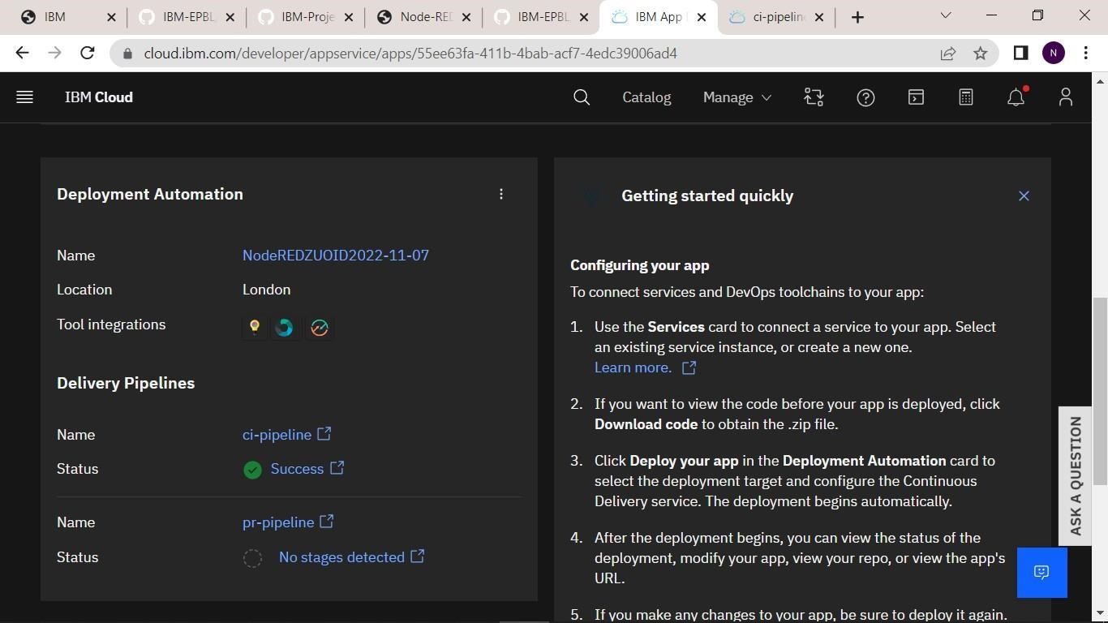

Step 6: Dragged and dropped components into the editor.

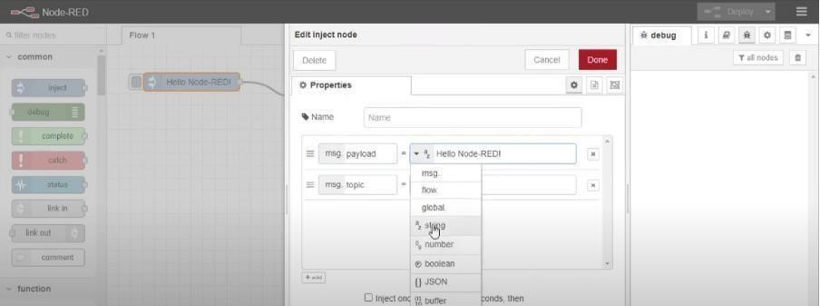

Step 7: Editing some values of the properties.

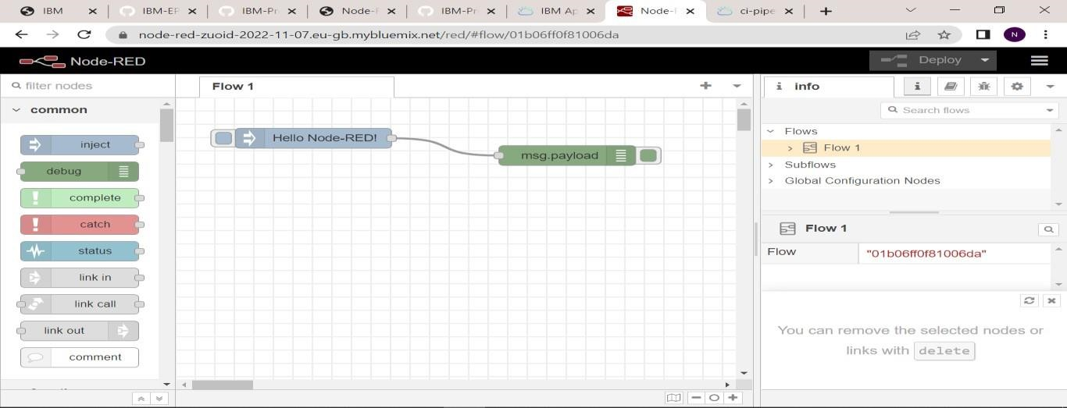

Step 8: Successfully deployed the app.

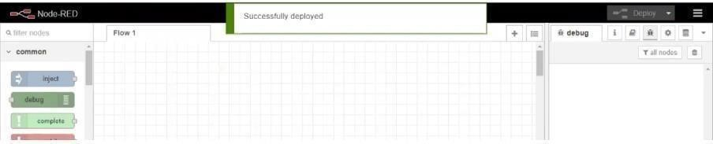

**Result:**

Successfully created a Node RED service on IBM Cloud.